YOUR BODY ON ANXIETY
Because anxiety is not all in your head.
LEARN YOUR BODY'S ALARM LANGUAGE
Something real is happening - but it does not mean something is wrong. Your body is performing important emergency jobs. During a false alarm, those changes can feel weird or scary, but they are temporary and not dangerous.

HEAD  My head feels foggy, dizzy, or unreal.  Your breathing has powered up for action. But during a false alarm, those extra breaths can make your head feel a little dizzy or foggy. | 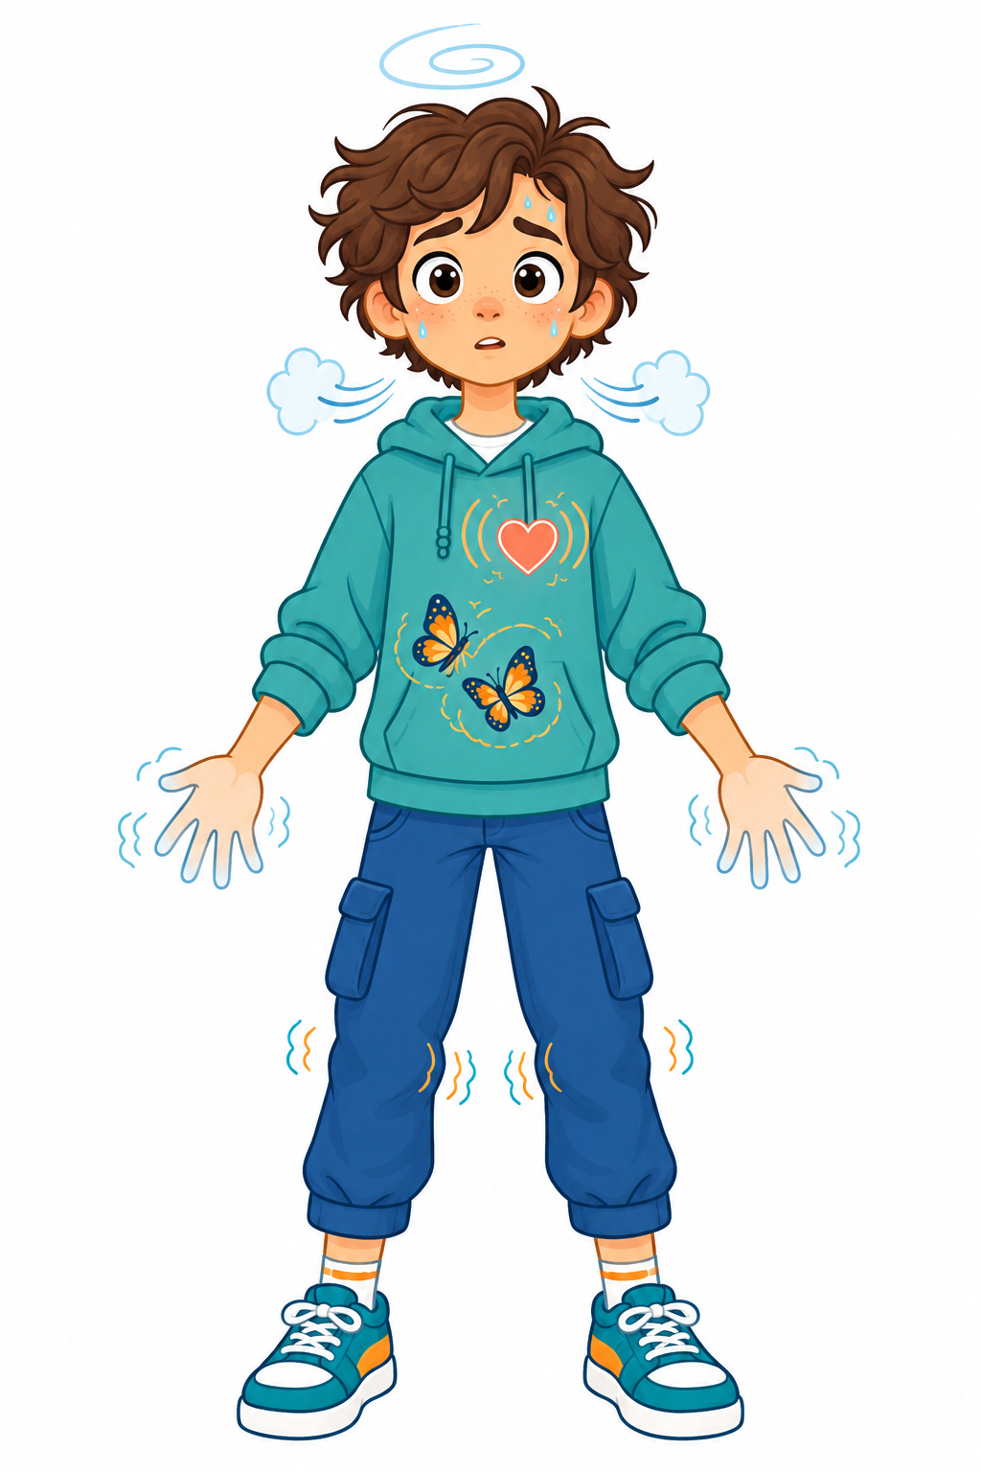 | STOMACH  I have butterflies or feel nauseous.  Digestion slows so your body can direct more energy toward responding to danger.
BREATHING  I feel like I can't get a good breath.  Your airways open and your breathing speeds up to bring in more oxygen for quick action. |  | SKIN  I feel hot and sweaty.  Your body produces sweat to keep you cool in case you need to move quickly.
HEART  My heart is racing.  Your heart pumps faster to send more blood and oxygen to the muscles that may need to act. |  | HANDS  My hands feel cold or tingly.  Blood shifts toward your heart and larger muscles so your body is ready for action.
VISION  Things look weird or distorted.  Your pupils widen to take in more light and help you spot possible danger. |  | MUSCLES  My body feels shaky or weak.  Your muscles tense and receive quick energy so they are ready to move.
REMEMBER  Helpful in a real emergency.  Uncomfortable - but not dangerous - during a false alarm. |  | WHOLE BODY  I feel like I'm losing control.  Your alarm has powered up your whole body to respond quickly. The feelings are intense, but you still choose what you do next.

WHERE DO YOU FEEL ANXIETY IN YOUR BODY?
Color, circle, shade, or draw where you notice your body alarm.
There are no right or wrong answers. Anxiety can feel different in every body - and it may feel different at different times.

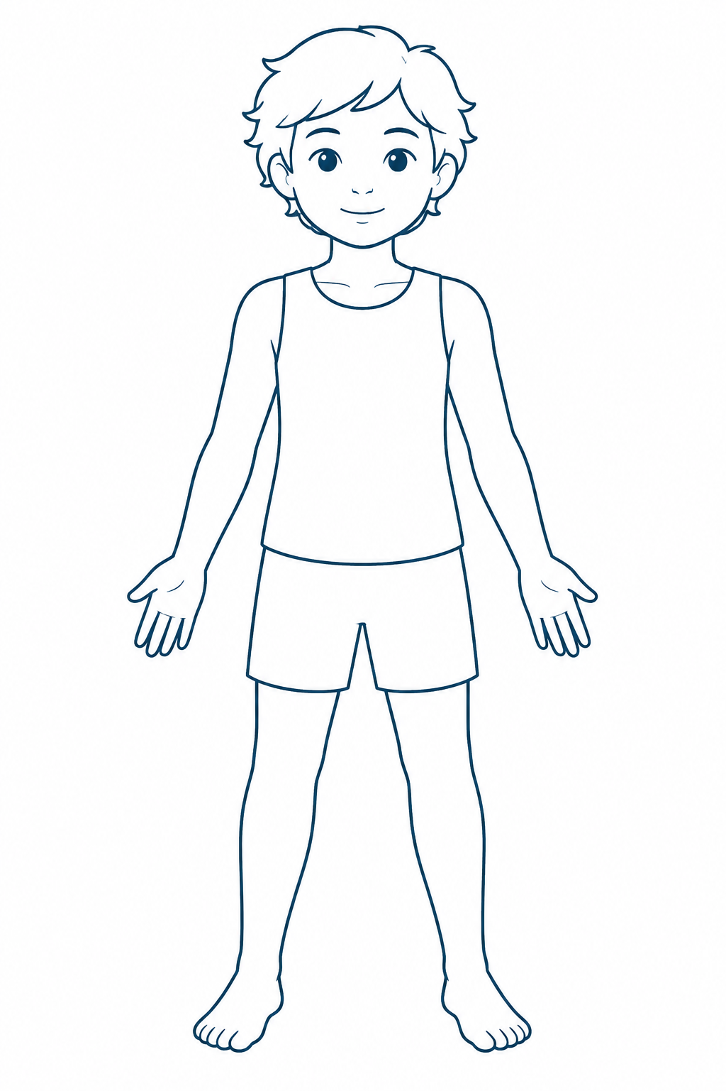 | What do you notice?  □ Foggy, dizzy, or unreal  □ Can't get a good breath  □ Racing heart  □ Weird or distorted vision  □ Butterflies or nausea  □ Hot and sweaty  □ Cold or tingly hands  □ Shaky or weak  □ Out of control  What else do you feel?  _______________________________________  _______________________________________  _______________________________________  Which feeling shows up first?  _______________________________________
These feelings are real. They do not automatically mean something is wrong.

YOUR BODY ON ANXIETY
Because anxiety is not all in your head.
MAP YOUR OWN BODY ALARM
Circle or check the sensations you notice when your alarm turns on.
□ My head feels foggy, dizzy, or unreal. | □ I feel like I can't get a good breath.
□ My heart is racing. | □ Things look weird or distorted.
□ I have butterflies or feel nauseous. | □ I feel hot and sweaty.
□ My hands feel cold or tingly. | □ My body feels shaky or weak.
□ I feel like I'm losing control. | □ Something else: __________________________

The sensation that grabs my attention most is:
________________________________________________________________________________

When I notice it, my alarm tells me:
________________________________________________________________________________
________________________________________________________________________________

What my body is actually doing:
________________________________________________________________________________
________________________________________________________________________________

CHECK THE ALARM
□ Real emergency: I need to act. □ False alarm: I can let it pass. □ Not sure: I can check the facts once.
My next helpful or brave step: _________________________________________________
I do not have to make the feeling disappear before I keep going.

